1.INTRODUCTION

1.1 Overview

This project helps us to learn many advanced things and also enrich our skills about the travel approval application for corporates and also we can learn many things technically.

1.2 Purpose

The purpose of the project is to earn more customers in accordance with the travel approval application.Practically we can earn more customers in the field of travel.

2.PROBLEM DEFINITION AND DESIGN

2.1 Empathy Map

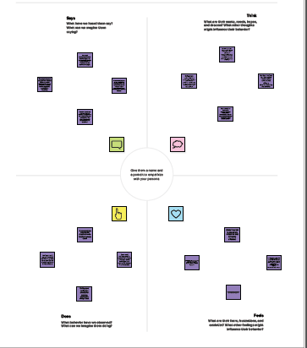

2.2 Ideation and Brainstroming

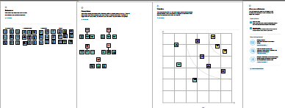

3.RESULT

3.1 Data Model

Object name and fields in the object

Object -1

Field label-Travel approval application for cooprporates

Data type-Milestones

3.2Activity and Screenshot

This project comprises of14 milestones starting with the creation of salesforce account and ending of the result page in this travel approval application for coorporates.Here are the folllowing 2 examples.

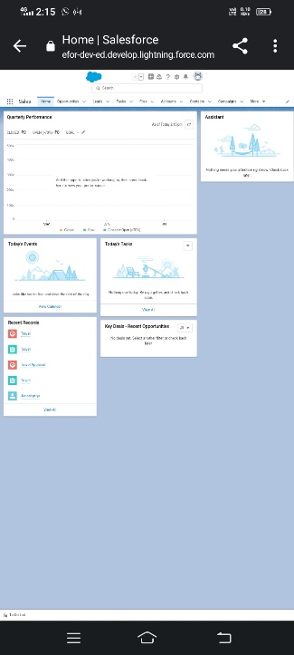 t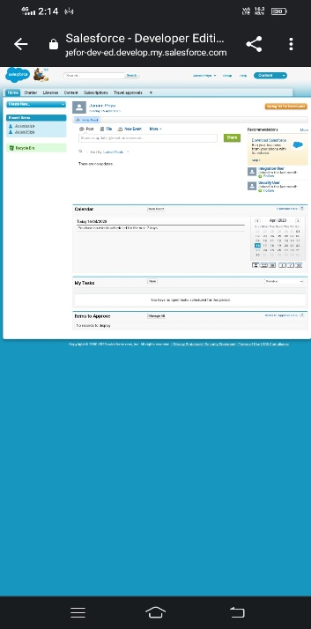

4. Trialhead profile public URL

Trial lead-https://trialblazer.me/me/id/jpriya89

Team Member 1-https://trailblazer.me/id/kirus26

Team Member 2-https://trailblazer.me/id/hemap43

Team Member 3-https://trialblazer.me/id/ishwm8

5.Advantages and Disadvantages

Advantages

1.Increase compliance and realise shortage.

2.Customise approval workflows.

Disadvantage

1.Currency exchange

6.Applications

It is applied in the future scope of the travellers and get upto date enhancement.

7.Conclusion

This project helps us to enrich the knowledge.

8.Future Scope

The future scope of the project is to develop the travelling technology.